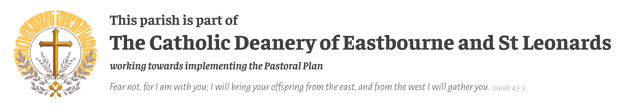
St Mary Star of the Sea Church 1 High Street Hastings, East Sussex, TN34 3EY Society of the Catholic Apostolate (Pallottines) Parish Priest: Fr Michael Wanjiru - Parish Clergy: Deacon Duncan Brown Parish Office: 1 High Street, Hastings, TN34 3EY - hastings@abdiocese.org.uk
Parish Treasurer: Carolyn Jones - pt.hastings@abdiocese.org.uk Parish Safeguarding: Chris Emary - sg1.hastings@abdiocese.org.uk Telephone: 01424 421263 - Please leave a message & we will call you back as soon as we can. Website: https://stmarystarofthesea.net

MASS INTENTIONS 6th to 20th June 2026
ELEVENTH SUNDAY IN ORDINDARY TIME
Saturday 13th June 6.00pm – Philomena Taylor RIP, 9thAnniversary
Sunday 14th June 10.00 am – Mass - Bernadette Clack RIP, Birthday Anniversary 11.30 am – Hastings Council 633 of The Knights of St Columba
Monday 15th June 10.00 am – NO MASS
Tuesday 16th June St Richard of Chichester, Bishop 10.00 am – Mass – Alan Turner RIP Anniversary Wednesday 17th June 10.00 am – Mass Thursday 18th June 10.00 am – Mass Friday 19th June 10.00 am – Mass Saturday20th June 10.00 am – Mass
SUNDAY THE MOST HOLY BODY & BLOOD OF CHRIST
Saturday 6th June Vigil of Sunday 6.00pm – Pro Populo - Corpus Christie Procession
Sunday 7th June 10.00 am – Mass 11.30 am – SCA Special Intention
Monday 8th June 10.00 am – NO MASS
Tuesday 9th June St Ephrem, Dr, Deacon, St Columba, Abbott 10.00 am – Mass Wednesday 10th June 10.00 am – Mass Thursday 11th June St Barnabas Apostle 10.00 am – Mass Friday 12th June The Most Sacred Heart Jesus 10.00 am – Mass Saturday13th June Our Lady on Saturday 10.00 am – Mass –

The Arundel & Brighton Diocesan Trust is a registered Charity, No 252878



Confession every Saturday after 10 am and 6pm Mass Baptisms are being held once a month. First Holy Communion, Confirmation and RCIA Programmes – registration for next year’s classes will begn in September 2026 look out for notices in the Newsletter
We warmly welcome the arrival of our new Parish Priest Fr Mike Wanjiru from East Africa, this is his first time away from Africa and may he feel the love that we all share in our Parish and enjoy his time with us. All the Parishioners who have been at Fr Mike’s Masses have taken him into their hearts and are thanking God that he has come to us. Ad multos annos!
St Mary Star of the Sea Community Club Meets weekly on Mondays at 10.15 am in the hall under the church. We have tea/coffee and then a guest speaker. We finish around 11.45 and everyone over 50 is welcome to join us.
Monday Men’s Group Prayer meeting & social is held every fortnight in the church at 7.30 pm. All men welcome. Next meeting Monday, 1st & 15th & 29th June.
Laudato Si Group We meet fortnightly on Tuesdays at 7pm, All welcome. Next meeting is on 9th June & 23rd June
Grandparent & Older Persons Group will resume soon. Keep a watch on the newsletter for details.
Carlos Acutis Holy Hour is held 6pm till 7pm on the first Wednesday of every month.
Yearly Pilgrimage to Poland will be held this September from 20th to 26^{th,} and is being arranged by Ilona on 07904 680885 who is with Eastbourne Catholic Church Christ the King. Prices are £995.00 per person sharing and £1200 in a single room. Please contact her for more details.
OUR JOURNEY TO BECOMING A NEW PARISH - Ultimately the new Parish will be overseen by a Priests Team, moderated by Fr Kevin Dring. They will work closely with a Leadership Team of clergy and lay reps, and with Hub Pastoral Teams of clergy and lay representatives from across our churches, in the development of our Pastoral Plan and our shared mission. The West Hub covers Eastbourne, Polegate, Hampden Park, Hailsham, and the East Hub covers St Leonards, Hastings, Bexhill, Battle and Rye. East Hub Secretary: Elizabeth Fitch stleonards@abdiocese.org.uk 01424 602077
West Hub Secretary: Cheryl Wood, eastbourneolor@abdiocese.org.uk 01323 723222
Deanery Website: www.eastbourne-stleonards.org.uk

LATEST DEANERY UPDATE - We have had a first meeting of a new Deanery Leadership Group, some priests and lay people from across the deanery. They will be working closely with the team of parish priests, and with our Hub Leadership groups to build on the good work that he has already been done over the past year in beginning to build foundations for our parishes coming together and working and sharing closely in the mission of the Church. From September, by which time we may (please God) have a good new Bishop in post, the work of these various groups will begin to impact more directly within the church communities, inviting everyone to play their part in the important work ahead. Everything we do will only be done if it clearly aims to build up our communities in strong faith, to support the most needy, and to reach out to share the Good News with all those around us. God bless – Fr Kevin

