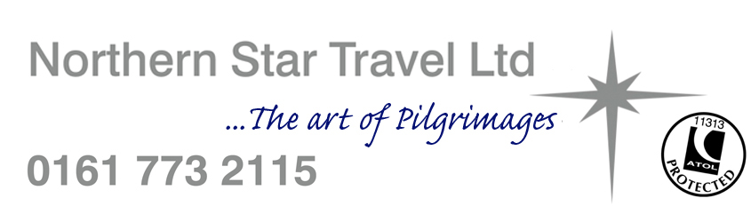
GROUP TRAVEL QUOTATION No: 2026-2028

GROUP LEAD NAME: Ilona Hollands
ADDRESS:

TELEPHONE: 07904 680885
E-Mail: illona.darkblue@sky.com

DEPARTURE DATE: 20 Sept 26 RETURN DATE: 26 Sept 26 No: DAYS: 7

TOUR DESCRIPTION: Poland by air from Gatwick

COST PER PERSON: £995 sharing, £1200 in single room.

COST INCLUDES:
- Return flights Gatwick - Krakow
- Airport duty and passenger taxes.
- 1 suitcase per person for the aircraft hold.
- 6 nights half board Krakow.
- Excursions as per the itinerary.
- English speaking guide/tour leader to accompany the group

WHAT IS EXTRA: Travel insurance
3 – 17 years of age £35
18 – 50 years of age £49
51 – 65 years of age £59
66 – 79 years of age £79
80 – 90 years of age £129
.

CONDITIONS: Minimum group size 20 paying passengers.
1 x free place for priest in single room.

ADDITIONAL COMMENTS……..

A deposit of £300 per person would be required to make the booking.

QUOTATION BY: Adrian Duffy DATE: April 26

Poland Pilgrimage

Day 1 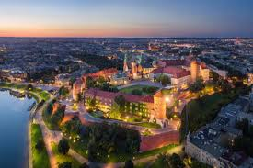
Depart your chosen airport for the flight to Krakow, on arrival reclaim your baggage & join the waiting coach for the transfer to the hotel in Krakow which will be the base for 6 nights on dinner, bed & breakfast basis, Mass to be celebrated in St Mary’s Basilica.

Day 2 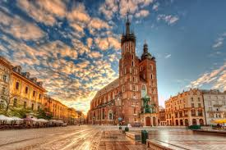
Today you will be given a guided tour of Krakow, including a visit to the Bishop’s Palace in which the Holy Father Pope John Paul II resided on each of his Pilgrimages to Krakow. The programme also includes a visit to St Mary’s Church (for Mass) where John Paul II gave sermons and heard confession. There will also be a visit to Wawel Cathedral where as Bishop Karol he went at Christmas to sing carols.

Day 3 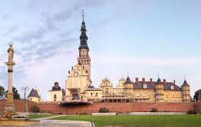
Today we travel to Czestochowa (the major Marian shrine in Poland) a town of special importance to John Paul II. He stayed there six times as Pope and chose it as the place for the 6th World Youth Day. It was also the first town in the world whose offer of honorary citizenship he accepted. Mass will be celebrated in the Jasna Gora Monastery.
Possibility of visiting the museum of 600th Jubilee of the shrine.

Day 4 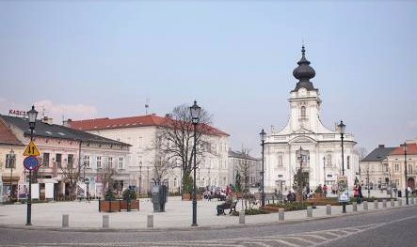 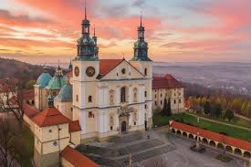
We begin today by visiting Wadowice where you will visit the Basilica of the Presentation of the Blessed Virgin Mary for Mass. You will visit Pope John Paul II’s family home, nowadays a museum, which documents his life and work as a priest in Poland up till the time when he was elected Bishop of Rome and left the country for good. as well as try the famous cream puff cakes – a favourite of the Pope as a child.
Possibility of visiting Kalwaria Zebrzydowska – the Polish Jerusalem, is a breathtaking cultural landscape of great spiritual significance. Its natural setting – in which a series of symbolic places of worship relating to the Passion of Jesus Christ and the life of the Virgin Mary was laid out at the beginning of the 17th century – has remained virtually unchanged.

Day 5 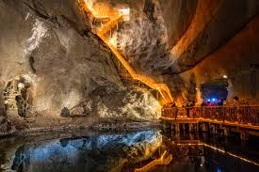 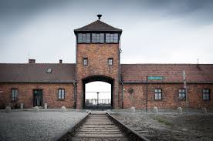
This morning, we visit the Salt Mines following the Pilgrims route, Mass will be celebrated in the chapel in the Salt Mines. In the afternoon there will be a visit to the concentration camp Auschwitz Birkenau for a guided visit.

Day 6 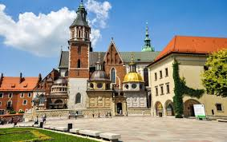
This morning, we will visit The Divine Mercy Shrine in Krakow Lagiewniki, and the Divine Mercy Basilica where we will celebrate Mass. We then visit the Saint John Paul II centre before returning mid-afternoon to Krakow.

Day 7
Depart Krakow today for the flight back to the UK.

