Eucharistic Miracles Exhibition
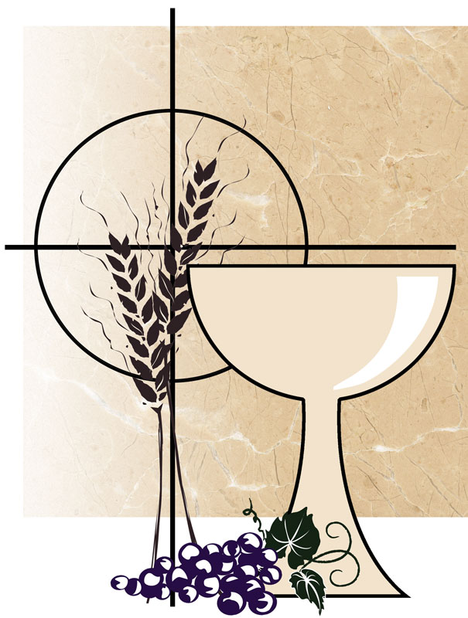
At St. Mary Star of the Sea Church Hastings.
From 30th November – 15th December

The Eucharistic Miracle Exhibition, created by Blessed Carlo Acutis, will be on display in the church and will remain until 15th December 2024. Everyone is encouraged to make time, perhaps dropping in during the week, to look more closely, to pray and reflect on the reality of these events. The greatest miracle happens at every Holy Mass. Eucharistic miracles are meant to help confirm our faith in the presence of the Body and Blood of Christ in the Eucharist. These miracles direct our attention to look beyond the appearances of bread and wine, and to the hidden reality of the True Presence of Our Lord. Please encourage others, family, friends, neighbours, the curious, regardless of faith, to “Come and See”..
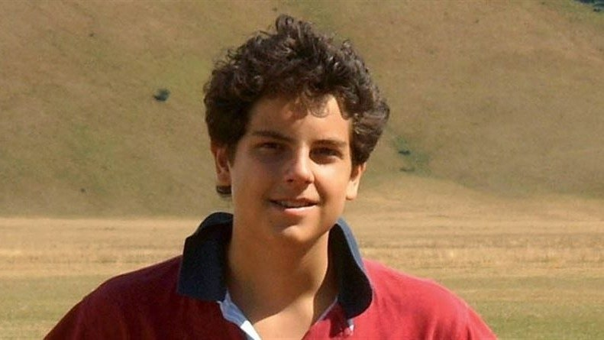

Blessed Carlo Acutis – 1991 to 2006: A Millennium Saint
Carlo was eleven when, by chance, he became aware of the Eucharistic Miracle of Lanciano, an event scientifically verified. It was the first of many he was to discover. Aware of an importance which could not be ignored, he decided to use his knowledge of computers and to bring the truth of the mystery of Jesus’ real presence in the Eucharist to the forefront of people’s understanding. He catalogued over 160 miracles, visiting many with his parents, and displayed the historical documentation and scientific analysis on a website for all the world to see the purpose behind this exhibition:
“Jerusalem is in each church. Why be discouraged? God is always with us, and He will never abandon us. But how can we understand this truth? There are so many people who are ready to get into interminable lines to attend a concert or a soccer game. Yet, I have a hard time seeing the same lines in our church entrances. The whole world could meet Jesus there. Let us think about it. This is serious! Jesus is physically present in our midst as He was with His disciples while He was alive. Let us not leave the one who comes to help and support us on our earthly path on his own.”
Carlo’s life was a life of holy integrity, seeking to love Jesus in the Eucharist and in the poor and forgotten people of Milan. Brought up in a wealthy family, he shared the blessings of his own life with the needy, yet he did not seek notoriety but only desired to love with the heart of Jesus, all those people that he would encounter. He sought to be authentic, real, and approachable, completely rooted in the love of Jesus. He refused to be programmed or enslaved to ego and, although a teenager of these modern times, not to live solely for the fads of this world. He once said, “All people are born as originals but many die as photocopies.” He died on 12th October 2006, the eve of the Feast of Our Lady of Fatima, to whom he had a great devotion. “The Virgin Mother is the only woman in my life.” and “I never fail to keep the most gracious appointment of the day: recitation of the Holy Rosary
Carlo Acutis’ website: www.miracolieucaristici.org

