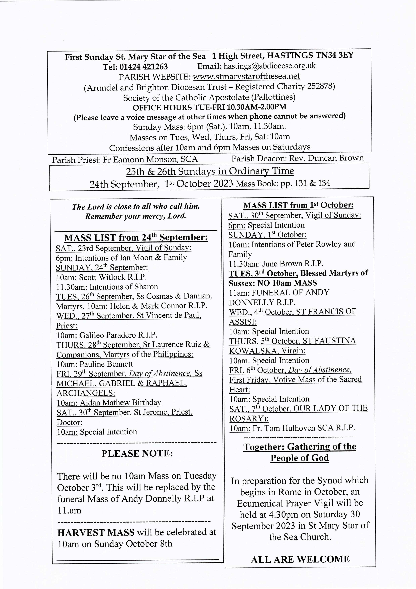

ST RICHARD’S CATHOLIC COLLEGE

If your child is approaching the period of transfer from primary to secondary schooling, very serious consideration must be given to decisions involved in the process of transition.

Our Open Evening takes place at St Richard’s Catholic College on

Wednesday 4th October 2023 from 6.00pm to 8.30pm.

--------------------------------------------------------------
From the Diocesan Safeguarding Office:

Please see below upcoming dates for our Creating a Safer Environment training sessions (all on Zoom). Please note, you only need to go to one training session.
This training is aimed at PSRs, Group Leaders, and Coordinators of activities in Parishes, who also need to know the elements of our Creating a Safer Environment Policy. Just email Safeguarding@abdiocese.org.uk to register.
Wednesday 11th October 10:00-11:30
Thursday 26th October 14:00-15:30
Tuesday 7th November 19:00-20:30
---------------------------------------------------------------------
DIVINE MERCY PRAYER GROUP

The following are the upcoming dates for the meetings that take place downstairs in the presbytery at 3pm: October 2nd, 16th and 30th. November 13th, 27th. December 11th
___________________________________________________________
PARISH MEN’S GROUP:
Next meeting will be in the church on Monday 2nd October at 7.30pm and fortnightly from then on. All men are warmly welcome.

Food Bank Please put donations of disposable nappies & in-date, non-perishable foods in the basket in the church foyer.
----------------------------------------------------------------------------------------------------------------------------------------------------------Activities in the hall
The St. Mary Star of the Sea Community Club Meets on Mondays after the 10am Mass for interesting talks and tea and coffee. All are welcome.

WE HAVE ALSO RESTARTED OUR REGULAR TEA, COFFEE & BISCUITS AFTER 10 O'CLOCK MASS ON SUNDAYS. LOOKING FORWARD TO SEEING YOU
GRANDPARENTS GROUP meets for Mass at 10am on the third Wednesday of every month, followed by a meeting in the hall. Honorary grandparents are also welcome.
--------------------------------------------------------------------------------------
From the Good Shepherd Parish: On the third Tuesday of every month St. Vincent de Paul Society are hosting afternoon tea from 2pm-4pm

