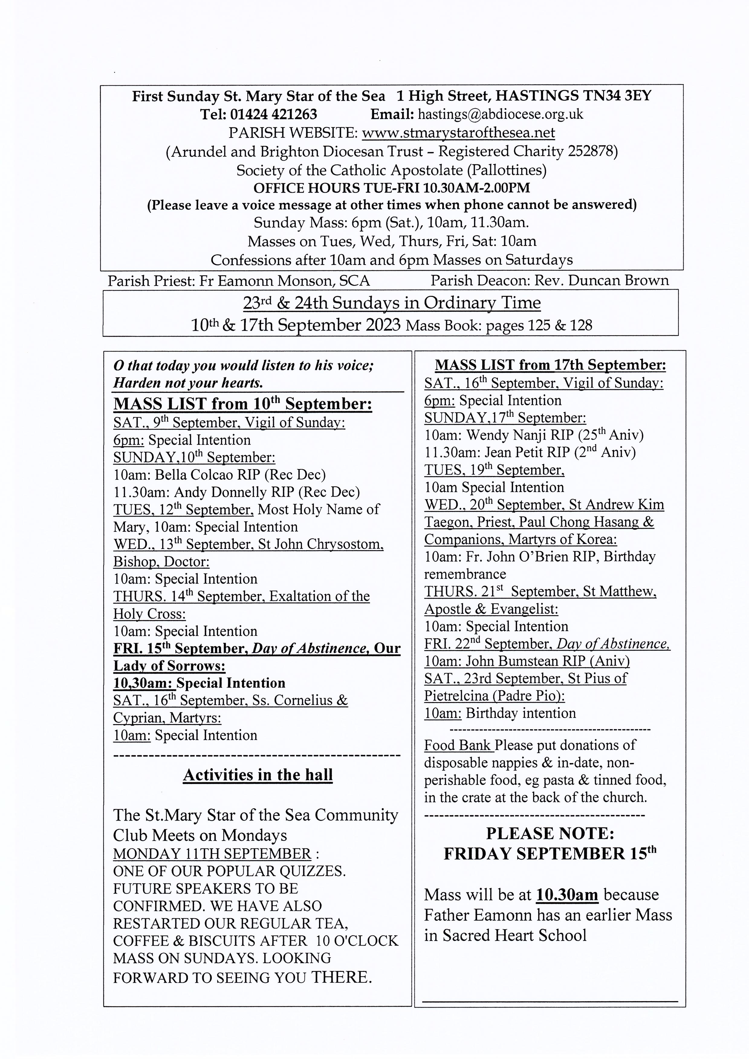

ST RICHARD’S CATHOLIC COLLEGE

If your child is approaching the period of transfer from primary to secondary schooling, very serious consideration must be given to decisions involved in the process of transition.

With kind permission of the Headteacher, I cordially extend an invitation to you and your child to attend an evening presentation at Sacred Heart Catholic Primary School on

Tuesday 12th September 2023 at 6.30pm when I, together with members of the Leadership and Management Team, Pastoral Leader of Year 7 and SENCo, shall be delighted to talk to you about St Richard’s Catholic College.

Our Open Evening takes place at St Richard’s Catholic College on

Wednesday 4th October 2023 from 6.00pm to 8.30pm.

Together: Gathering of the People of God An Ecumenical Prayer Vigil will be held at 4.30pm on Saturday 30 September 2023 in St Mary Star of the Sea Church.
--------------------------------------------------------------
From the Diocesan Safeguarding Office: Please see below upcoming dates for our Creating a Safer Environment training sessions (all on Zoom). Please note, you only need to go to one training session.
This training is aimed at PSRs, Group Leaders, and Coordinators of activities in Parishes, who also need to know the elements of our Creating a Safer Environment Policy. Just email Safeguarding@abdiocese.org.uk to register.
Wednesday 11th October 10:00-11:30
Thursday 26th October 14:00-15:30
Tuesday 7th November 19:00-20:30
---------------------------------------------------------------------
Grandparents' and Older Persons’ Group:
Following the August break we are meeting again on Wednesday 20 September, after the 10.00 am Mass, in the church hall for coffee, tea and a chat and catch up.
At the July gathering it was suggested that after our meeting we should retire to the Isobel Blackman Centre in Winding Street, Hastings, for lunch. This has been arranged for 12.30 pm.
We can walk there as a group if you are not sure where Winding Street is, to arrive by about 12.15.
The cost of the meal is £9.00 (IBC members £8.00) for two courses. The main course is beef lasagne with garlic bread and salad (or split pea and spinach Dhal with basmati rice) followed by blackcurrant and thyme ice cream sandwich for desert
We need to know how many people would be interested so could you confirm your attendance by Tuesday 12 Sept at the latest.
Our phone number is 01424 754721 or 0747 998 5968. Please indicate which main course you wish to would like.
Looking forward to hearing from you.
---------------------------------------------------------
PARISH MEN’S GROUP: Next meeting will be in the church on Monday 18th September at 7.30pm and fortnightly from then on. All men are warmly welcome.
Items for the newsletter: If emailing notices for inclusion in the newsletter, please could you type them simply, in Times New Roman 14, without any formatting, and please no spaces between lines, bullet points etc which make it difficult to copy and paste. Also, please don’t send posters or photos. Many thanks and God bless.

