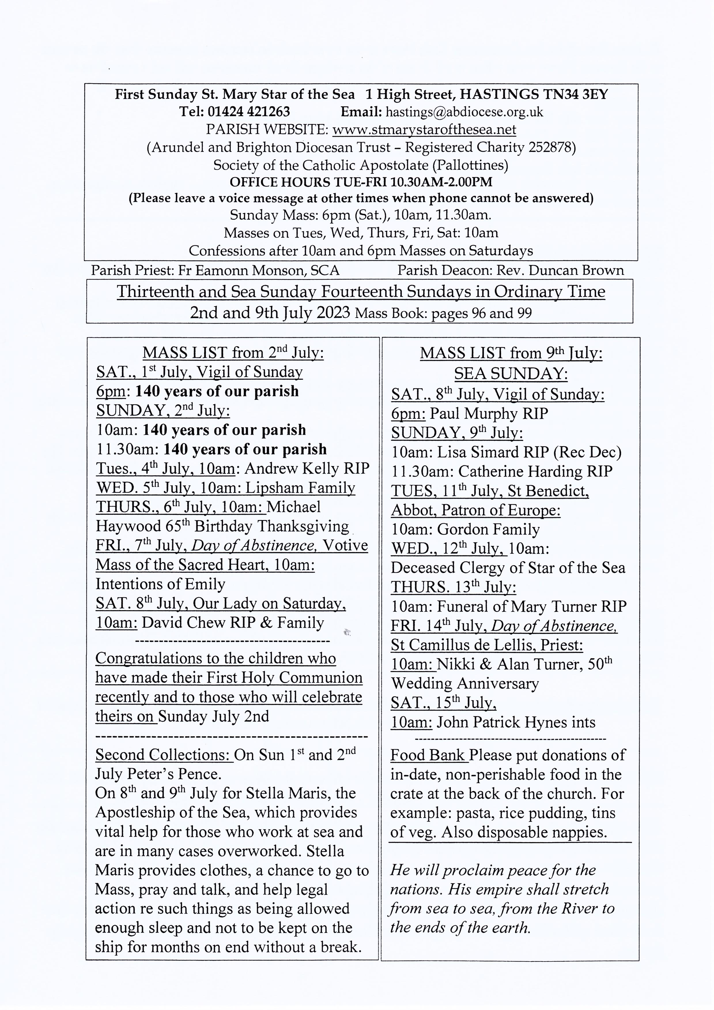

St. Mary Star of the Sea Community Club Meets in the church hall on Mondays (entrance from the car park in the Bourne) Please come along to all or one of the meetings for an interesting talk and a cup of tea or coffee. Refreshments 50p Annual subscription £5. Everyone over 50 is welcome. 10.15 to 11.45.
Programme:
Monday 3rd July NO MEETING. Outing to Chartwell (must be pre booked).
Monday 10th July Quiz and games.
Monday 17th July Talk by Shirley Kleinot on her holiday in Rajasthan.
Monday 24th July Preparing for Old Town week.
Monday 31st Tour of St.Mary Star of the Sea church ,Tea and coffee with a large Tombola to raise money for the Two Towers Trust and the church hall restoration.
-------------------------------------------------------------------------------------------------------------------------------

Grandparents' and Older Persons’ Group:
Our next meeting will be on Wednesday 19 July in the church hall, after the 10.00am Mass, at St. Mary Star of the Sea.
Now that we are getting to know each other better it is intended that we exchange ideas around preparing interesting, fruitful, enjoyable and productive meetings for the autumn and beyond over tea and coffee.
Please do join us, even if you have not attended the group before, and let us know what you think.
There will be no meeting in August so our next gathering will be held on Wednesday 19 September with details to follow later.
You may be interested in Faith Café meetings on Zoom which take place every second Tuesday of the month. Further information and the link can be found by googling 'Catholic Grandparents Association Faith Café'. Any one is welcome to participate.
Saturday 22 July is the World Day of Prayer for Grandparents and the older person which Pope Francis calls us to celebrate. There will be Mass at Arundel Cathedral celebrated by Bishop Richard at 2.30pm. The theme will be: 'His mercy is from age to age'. Mass will be followed by light refreshments in the Cathedral Centre. Further details may be found on the diocesan website, where bookings are now open.
Tuesday 26 September is the Diocesan Annual Formation Day at the St. Philip Howard Centre in Crawley. The topic this year is: 'How do we pass on our faith?' Further details are on the diocesan website and it is suggested that bookings are made as soon as possible if you wish to attend.
Google 'Catholic Grandparents' Association News Letter ' to find out more about this great organisation.
----------------------------------------------------------------------------------------------------------------------------------
PARISH MEN’S GROUP meets in the church on Monday 10th July at 7.30pm and every fortnight.
All men warmly welcome.
On Saturday 29th July and every last Saturday of each month, we have returned to the practice of the blessing of the sick during the 10am Mass. This is followed by a cup of tea or coffee in the parish room (one step from the back of the church) and a biscuit and chat.
----------------------------------------------------------------------------------------------------------------------------------

Coffee and tea are served in the hall under the church after 10 o'clock Mass on Sundays. Please use external entrance by the car park. All are warmly welcome.
---------------------------------------------------------------------------------------------------------------------------------
DIVINE MERCY PRAYER GROUP All are warmly welcome to join us on the following Mondays in 2023 in the presbytery on July 10th and 24th. August: no meeting for the whole month.
This weekend marks the 150th Anniversary of the Dedication of Arundel Cathedral and the 140th Anniversary of St. Mary Star of the Sea Church. We remember and give thanks to God for every person who has been part of this parish community throughout all these years, and we look to the future with confidence in the Holy Spirit as we renew the dedication of our lives to God the Father through His Son Jesus, in communion with Our Lady Star of the Sea, Queen of Apostles, Mother of Divine Love. St. Vincent Pallotti pray for us.

