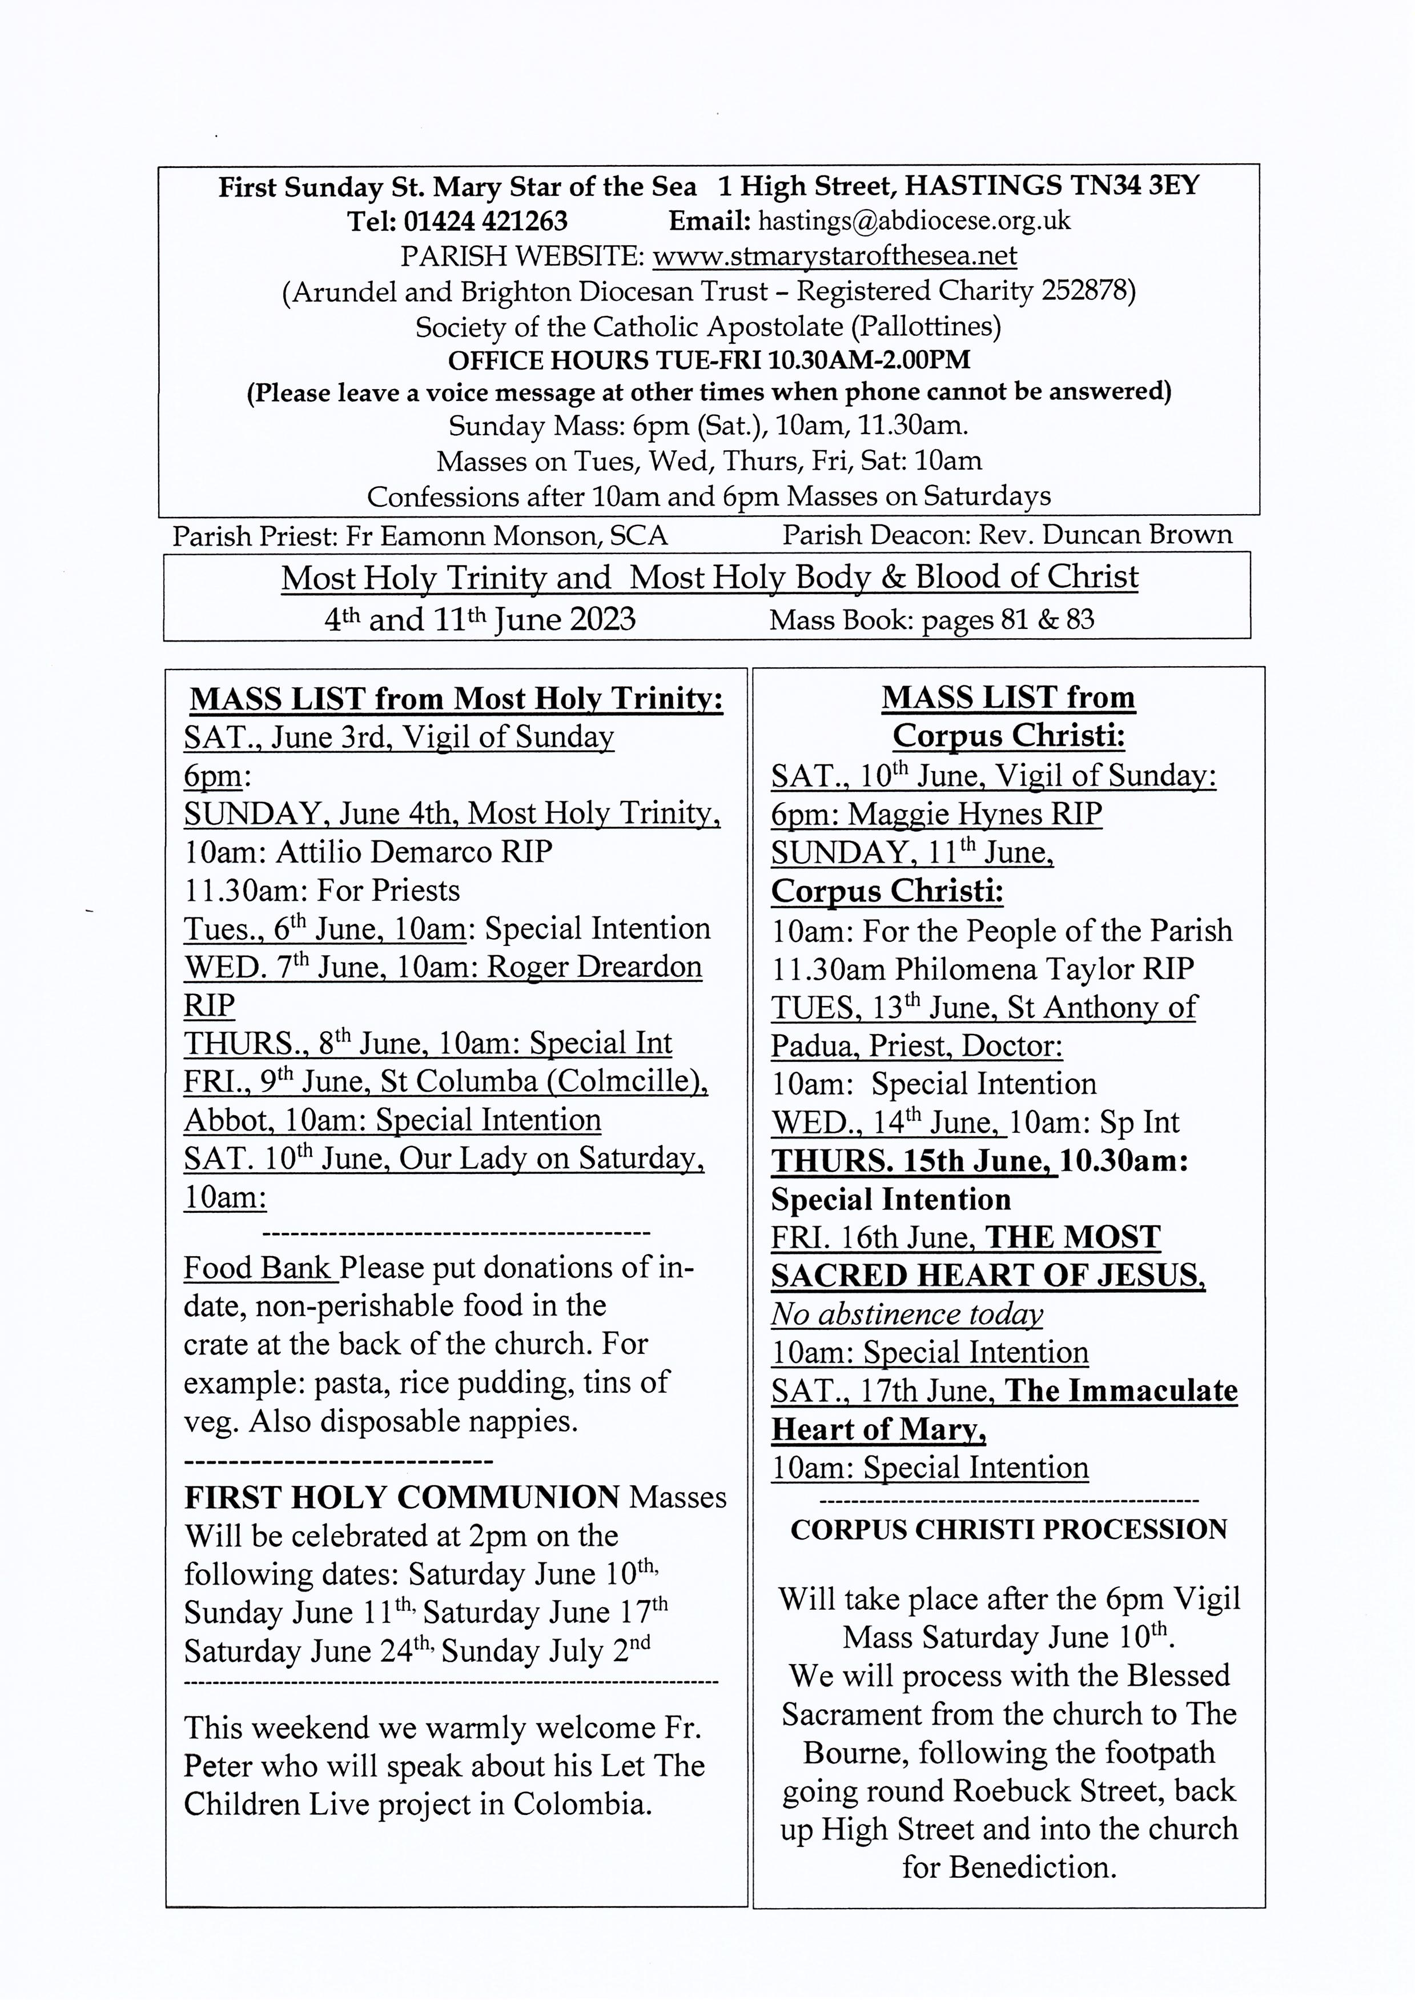

Knights of St Columba, Pilgrimage to Aylesford Priory

Sunday June 18th 2023 Mass with choir at 12 noon. Full-Knighthood Ceremony. St Columba’s relic will be present. Supreme Knight Brother Harry Welsh
Beautiful grounds to have a picnic in. A celebration, so bring all the family!
Everyone, non-Knights included, is very welcome. Covered space available should weather be inclement. Rosary procession 3:15 pm. The Friars, Aylesford, Kent ME20 7BX. For more information email Paddy Boyle at pgk_province12@ksc.org.uk
http://ksc.org.uk

---------------------------------------
St. Mary Star of the Sea Community Club
Meets in the church hall on Mondays (entrance from the car park in the Bourne) 10.30am - about 12pm. Please come along and join us for an interesting talk and a cup of tea or coffee.
Refreshments 50p Annual subscription £5
New members always welcome. Just come along to the parish hall for 10.30am.
---------------------------------------------
PARISH MEN’S GROUP
meets in the church on Monday 12th June at 7.30pm and every fortnight. All men warmly welcome.

On Saturday 27th May and every last Saturday of each month, there will be the blessing of the sick during the 10am Mass. This is followed by a cup of tea or coffee.
---------------------------------------------------------------------------------------------------------------
Coffee and tea are served in the hall
under the church after 10 o'clock Mass on Sundays. Please use external entrance by the car park. All are warmly welcome

DIVINE MERCY PRAYER GROUP
All are warmly welcome to join us on the following Mondays in 2023 in the presbytery on June 12th and 26th. July 10th and 24th. August: no meeting for the whole month.
--------------------------------------------------------------------------------------------------------------
SYNOD NATIONAL RESPONSE – THIRST for FORMATION?
Do YOU have a yearning to know how to be equipped to evangelise and share the good news of Mission? Contact: Sue Petritz. Diocesan Link for Arundel & Brighton nbcw@abdiocese.org.uk
Actively promoting the presence, participation & responsibilities of Catholic Women. Thank you for supporting the women of your diocese.
GRANDPARENT’S GROUP - Pilgrimage to the Shrine of Our Lady of Consolation at WEST Grinstead on 14 June, the second Wednesday in June, and will be in place of our normal meeting day.
The Priest’s House, Park Ln, West Grinstead, Horsham RH13 8LT - you will need to register your intention to attend on the Diocesan website. The day will commence at 11.00 with coffee and tea served from about 10.30
UPCOMING DIOCESAN MENTAL HEALTH COURSES:

- Sat 10 June - Horsham - One day Champion Course
- Sat 15 July - Worth - One day Champion Course
- 12/13/19/20 September - Online - Two Day Youth MHFA (4 evenings)
- Sat 4 November - Worthing - Half day MH Aware
Email simon.south@abdiocese.org.uk for more details.

PLEASE NOTE: MASS ON THURSDAY JUNE 15TH WILL BE AT 10.30AM

