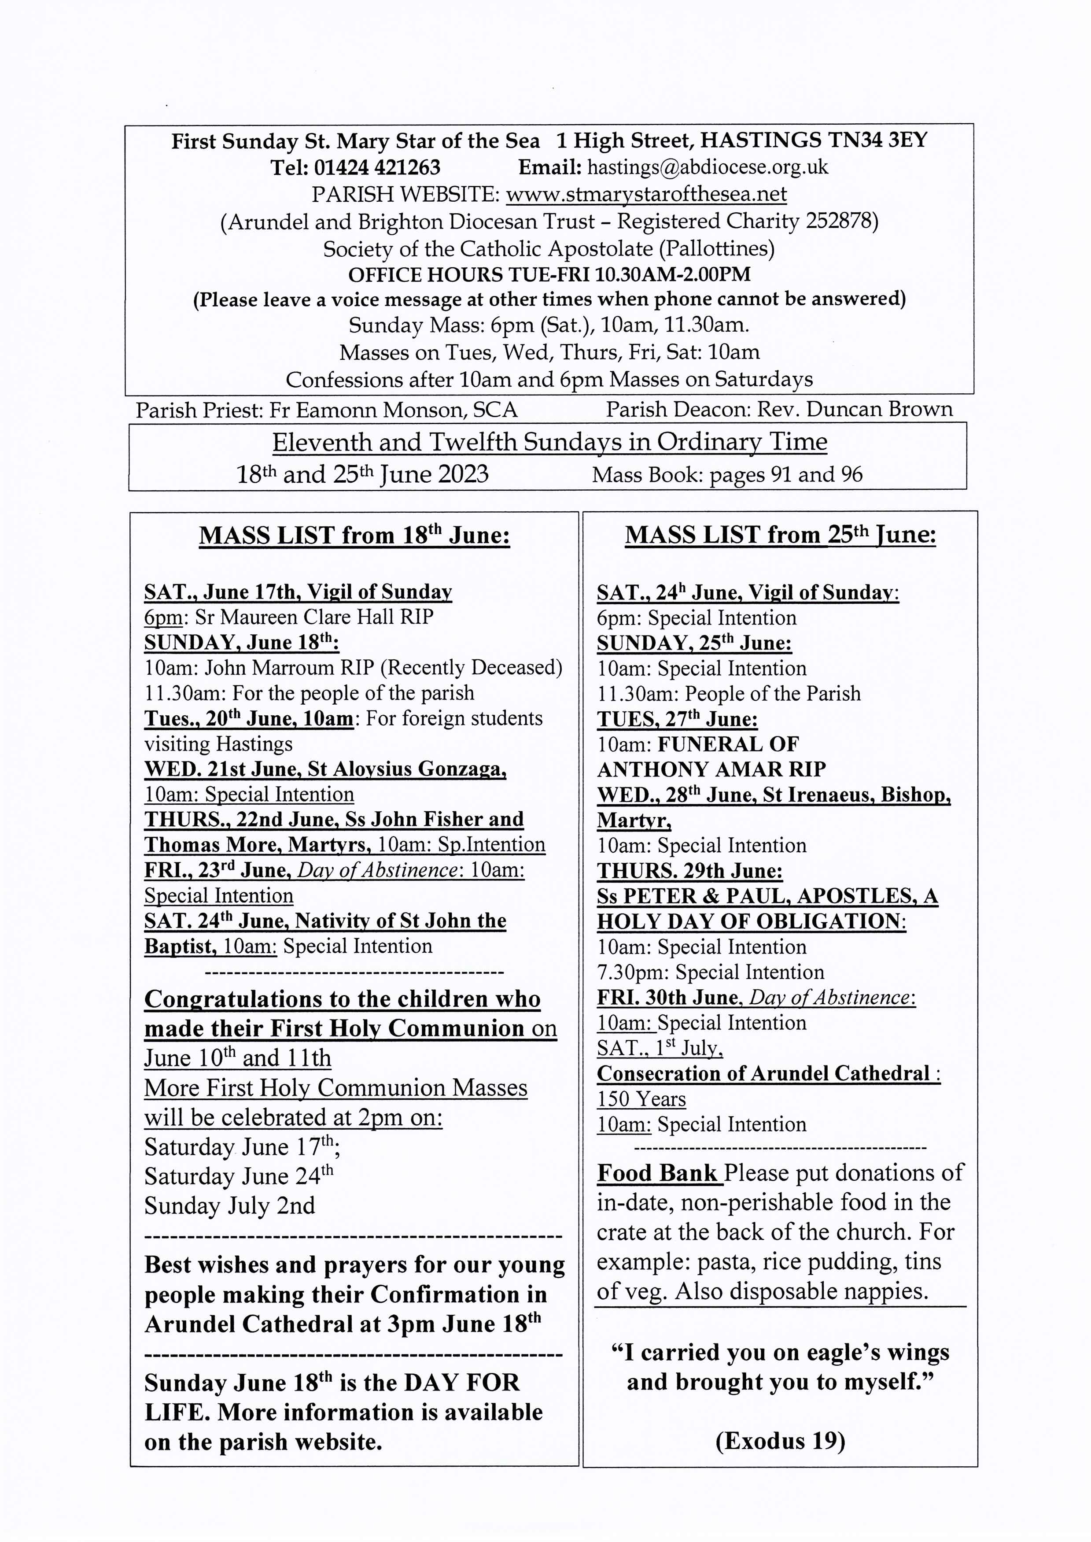

HAPPY FATHER’S DAY TO ALL OUR DADS

I fall on my knees before God the Father from whom all fatherhood takes its name, that he may grant you to be strengthened through his Spirit in the inner man, and that Christ may dwell in your hearts through faith; that you, being rooted and grounded in love, may have power to comprehend the breadth and length and height and depth, and to know the love of Christ which surpasses knowledge, that you may be filled with all the fulness of God. (Ephesians 3)
-----------------------------------------------------------------------------------------------------------------
Knights of St Columba, Pilgrimage to Aylesford Priory Sunday June 18th 2023. Mass with choir at 12 noon. Full-Knighthood Ceremony. St Columba’s relic will be present. Supreme Knight Brother Harry Welsh. Beautiful grounds to have a picnic in a celebration, so bring all the family! Everyone, non-Knights included, is very welcome. Covered space available should weather be inclement. Rosary procession 3:15 pm The Friars, Aylesford, Kent ME20 7BX. For more information email Paddy Boyle at gk_province12@ksc.org.uk http://ksc.org.uk
--------------------------------------------------------------------------------------------------------------------------------
St. Mary Star of the Sea Community Club Meets in the church hall on Mondays (entrance from the car park in the Bourne) 10.30am - about 12pm. Please come along and join us for an interesting talk and a cup of tea or coffee. Refreshments 50p Annual subscription £5
New members always welcome. Just come along to the parish hall for 10.30am.
---------------------------------------------
The Synodal Journey: Travelling with Great Expectations

A reflection on the continental stage of the Synod held in Prague 19.00-21.00 (BST), Wednesday 28th June 2023, via Zoom With Rt Rev Nicholas Hudson, Auxiliary Bishop of Westminster; Rev Fr Jan Nowotnik and Ms Sarah Adam, Reps at Prague Assembly
Please register via: http://tinyurl.com/2hh5x446
No fee for attendance, but donations welcome
---------------------------------------------------------------------------------------------------------------------------------

On Saturday 24th June and every last Saturday of each month, we have returned to the practice of the blessing of the sick during the 10am Mass. This is followed by a cup of tea or coffee in the parish room (one step from the back of the church) and a biscuit and chat.
--------------------------------------------------------------------------------------------------------------------------------

Coffee and tea are served in the hall under the church after 10 o'clock Mass on Sundays. Please use external entrance by the car park. All are warmly welcome
----------------------------------------------------------------------------------------------------------------------------------
DIVINE MERCY PRAYER GROUP All are warmly welcome to join us on the following Mondays in 2023 in the presbytery on June 26th. July 10th and 24th. Spring Bank Holiday, May 29th: no meeting. August: no meeting for the whole month.
--------------------------------------------------------------------------------------------------------------------
DAY OF LIFE - PRAYER TO ST. JOSEPH

Dearest Saint Joseph, at the word of an angel, you lovingly took Mary into your home. As God’s humble servant, you guided the Holy Family on the road to Bethlehem, welcomed Jesus as your own son in the shelter of a manger, and fled far from your homeland for the safety of both Mother and Child. We praise God that as their faithful protector, you never hesitated to sacrifice for those entrusted to you. May your example inspire us also to welcome, cherish, and safeguard God’s most precious gift of life. Help us to faithfully commit ourselves to the service and defence of human life - especially where it is vulnerable or threatened, Obtain for us the grace to do the will of God in all things. Amen.

