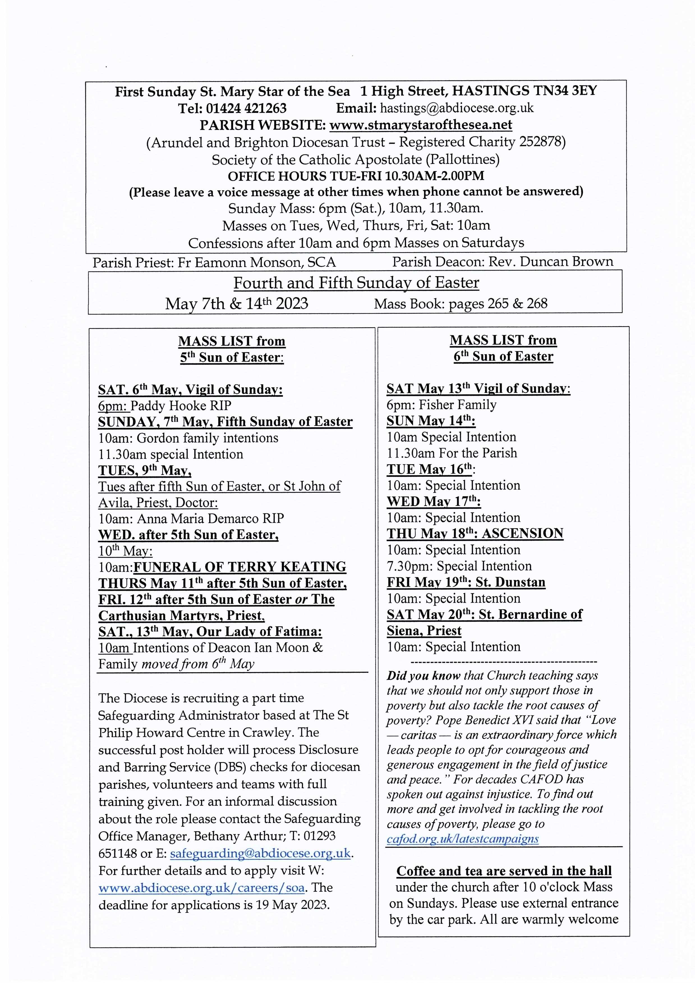
The hearing loop in the church has been tested and is in full working order. People with hearing aids should switch to Loop to ensure they have the benefit of this disability aid.

On the last Saturday of each month we have returned to the practice of the blessing of the sick during 10 Mass. This is followed by a cup of tea/coffee in the parish room (one step from the back of the church) and a biscuit and chat. The next dates for this are
Saturday April 29th and Saturday May 27th.

Grandparents Group Meeting 17 May

After Mass on 17 May at 10.00 in St. Mary Star of the Sea, Fr. Eamonn has kindly offered to talk to the grandparents' group on the subject of spirituality of children. We do hope you can join us.

At this meeting people who wish to join us for the grandparents' pilgrimage to the Shrine of Our Lady of Consolation at WEST Grinstead will have the opportunity to make arrangements to share transport and costs with those willing to offer lifts in their cars. We will need to register those who will be attending so please give us your names at the meeting. The pilgrimage will be on 14 June, the second Wednesday in June, and will be in place of our normal meeting day.

This is a day of sharing and prayer with other Grandparents led by Bishop Richard to include Mass, Benediction, Rosary, tours of the secret chapel and lots of chat. Please bring a packed lunch and a travel mug if possible. Please dress appropriately for the weather. The day will commence at 11.00 with coffee and tea served from about 10.30 . If you wish to travel independently then the address is:

The Priest’s House, Park Ln, West Grinstead, Horsham RH13 8LT and you will need to register your intention to attend on the Diocesan website. Looking forward to seeing you on 17 May. Ellen, Johanna and David

Please note that photographs will be taken at this event. Pictures may feature in the weekly E-Bulletin, the diocesan Flickr feed or as a part of a news story on our website. If you have questions or concerns, please contact the Head of Communications at E: communications@abdiocese.org.uk
----------------------------------------------
DIVINE MERCY PRAYER GROUP
All are warmly welcome to join us on the following Mondays in 2023 in the presbytery at May 8th. May 22nd. June 12th and 26th. July 10th and 24th. We can do May 8th instead. Spring Bank Holiday, May 29th: no meeting. August: no meeting for the whole month.
---------------------------------------
St. Mary Star of the Sea Community Club
Meets in the church hall on Mondays (entrance from the car park in the Bourne) 10.30am - about 12pm. Please come along and join us for an interesting talk and a cup of tea or coffee.
Programme:
May 8th Club closed. Coronation Bank Holiday
May 15th Coronation Party.
Mon. 22nd May. Romans in Britain. Talk by Claire Power.
Mon. 29th May: Bank Holiday. No club.
Refreshments 50p Annual subscription £5
New members always welcome. Just come along to the parish hall for 10.30am.
---------------------------------------------
PARISH MEN’S GROUP meets in the church on Monday 15th May at 7.30pm and every fortnight.
All men warmly welcome.

