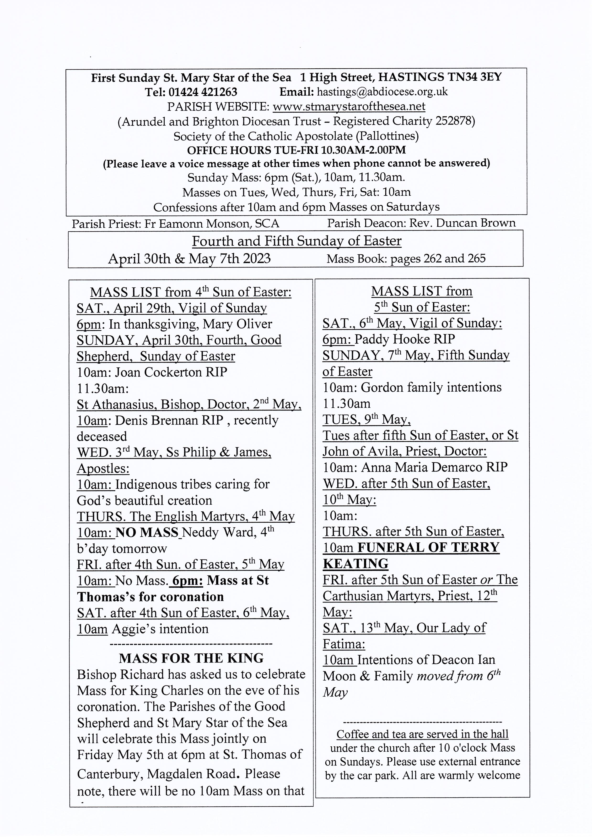
The hearing loop in the church has been tested and is in full working order. People with hearing aids should switch to Loop to ensure they have the benefit of this disability aid.

On the last Saturday of each month we have returned to the practice of the blessing of the sick during 10 Mass. This is followed by a cup of tea/coffee in the parish room (one step from the back of the church) and a biscuit and chat. The next dates for this are
Saturday April 29th and Saturday May 27th.

St Mary Star of the Sea and Good Shepherd Parishes Grandparents' Group
(Including honorary grandparents, Godparents and all interested in the life of our young people.)
The May meeting will be Fr. Eamonn talking about nurturing the spiritual life of children. If you have any suggestions that you would like Fr. Eamonn to incorporate into his talk feel free to tell us at our April meeting.
The June meeting will be the pilgrimage to the shrine of Our Lady of West Grinstead on 14th June at 11.00am with the Bishop. Further details to follow.
Johanna and David Giles, Ellen Staples
----------------------------------------------

DIVINE MERCY PRAYER GROUP
All are warmly welcome to join us on the following Mondays in 2023 in the presbytery at May 8th. May 22nd. June 12th and 26th. July 10th and 24th.
Bank Holiday May 1st: no meeting. We can do May 8th instead. Spring Bank Holiday, May 29th: no meeting. August: no meeting for the whole month.
---------------------------------------
St. Mary Star of the Sea Community Club
Meets in the church hall on Mondays (entrance from the car park in the Bourne) 10.30am - about 12pm. Please come along and join us for an interesting talk and a cup of tea or coffee.
Programme:
May 1st Club closed Bank Holiday
May 8th Club closed. Coronation Bank Holiday
May 15th Coronation Party.
Mon. 22nd May. Romans in Britain. Talk by Claire Power.
Mon. 29th May: Bank Holiday. No club.
Refreshments 50p Annual subscription £5
New members always welcome. Just come along to the parish hall for 10.30am.
---------------------------------------------
PARISH MEN’S GROUP
meets in the church on Monday 1st May at 7.30pm and every fortnight.
All men warmly welcome.
PLEASE NOTE

There will be no Mass on Thursday May 4th as Father Eamonn will be attending a training course for priests.

