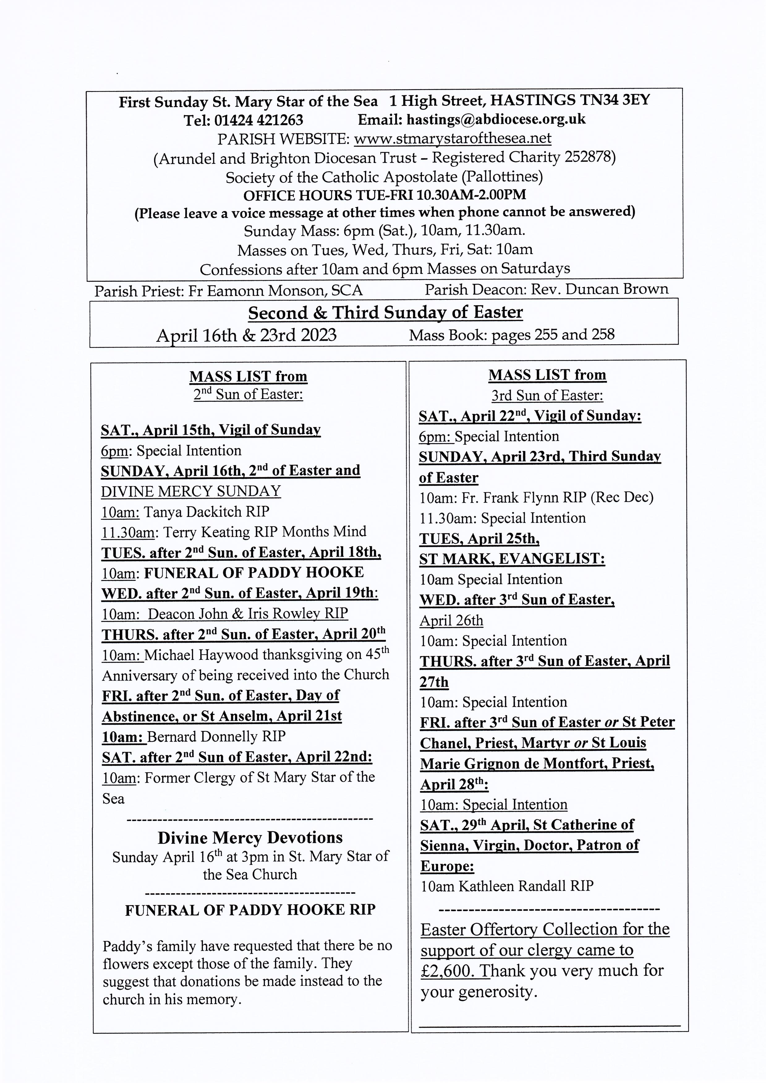

St Mary Star of the Sea and Good Shepherd Parishes Grandparents' Group
(Including honorary grandparents, Godparents and all interested in the life of our young people.)

Our next meeting will take place in the crypt of St Mary Star of the Sea, on Wednesday 19th April following the 10.00 am Mass which will be said for all grandparents. All are welcome to join us for coffee/tea. Our April gathering will be sharing thoughts around books we have read that have inspired or helped us. (Please feel free to bring along anything you wish to share.) We will also be looking at leaflets about Passing on The Faith.

The May meeting will be Fr. Eamonn talking about nurturing the spiritual life of children. If you have any suggestions that you would like Fr. Eamonn to incorporate into his talk feel free to tell us at our April meeting.

The June meeting will be the pilgrimage to the shrine of Our Lady of West Grinstead on 14th June at 11.00am with the Bishop. Further details to follow.
Johanna and David Giles, Ellen Staples
----------------------------------------------

DIVINE MERCY PRAYER GROUP
All are warmly welcome to join us on the following Mondays in 2023 in the presbytery at 2.30pm: April 17th. May 8th. May 22nd. June 12th and 26th. July 10th and 24th.
Sunday 16th April 2023 is Divine Mercy Sunday
Bank Holiday May 1st: no meeting. We can do May 8th instead. Spring Bank Holiday, May 29th: no meeting. August: no meeting for the whole month.
---------------------------------------
St. Mary Star of the Sea Community Club
Meets in the church hall on Mondays (entrance from the car park in the Bourne) 10.30am - about 12pm. Please come along and join us for an interesting talk and a cup of tea or coffee.
Programme:
April 17th. Find out more about the Credit Union.
April 24th. Coffee/Tea and chat and games.
May 1st Club closed Bank Holiday
May 8th Club closed. Coronation Bank Holiday
May 15th Coronation Party.
Mon. 22nd May. Romans in Britain. Talk by Claire Power.
Mon. 29th May: Bank Holiday. No club.
Refreshments 50p Annual subscription £5
New members always welcome. Just come along to the parish hall for 10.30am.

Coffee and tea are served in the hall under the church after 10 o'clock Mass on Sundays. Please use external entrance by the car park. All are warmly welcome!

PARISH MEN’S GROUP
meets in the church on Monday 17 April at 7.30pm and every fortnight.
All men warmly welcome.

Our new parish email address is hastings@abdiocese.org.uk

