NEWSLETTER
  - ONLINE

LITTLE STARS PLAYGROUP  from 0 to 5 at Sacred Heart School, Old London Road.  Every Thursday term time 9-11am. Free play, craft activities, singing, stories and snack time! Hot beverages for caregivers.  Fun, informal, friendly group all welcome. £3 per family. | Ministry of Welcome  You are warmly invited to a time of reflection and formation for the Ministry of welcome on Sat 15th October, 11am to 3.30pm in Holy Redeemer Church hall, Upper Church Road, Hollington, TN37 7AS. | CONFIRMATION  Application forms for the Sacrament of Confirmation programme are available this weekend after all Masses
 | CAFOD  THE SECOND COLLECTION THIS WEEKEND IS IN AID OF CAFOD. ENVLEOPES ARE AVAILABLE AT THE CHURCH ENTRANCE
PARISH MEN’S GROUP  THE GROUP MEETS IN THE CHURCH ON MONDAY OCTOBER 17TH AT 7.30PM AND EVERY FORTNIGHT. ALL MEN ARE WELCOME | 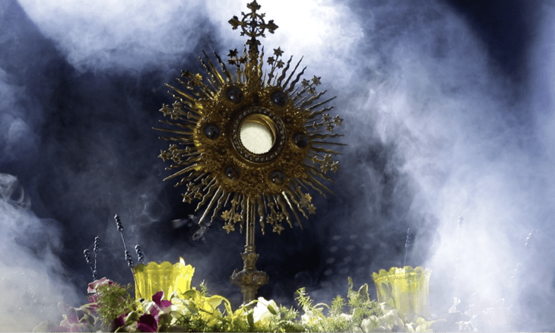
THE SOCLIA CLUB  is now meeting on Mondays in the hall under the church. 10.30 to 12. Everyone over 50 is very welcome. Please come along and find out what we do. | DIVINE MERCY  PRAYER GROUP  Meets on the following Mondays in 2022 in the presbytery at 2.30pm.  10th Oct., 24th Oct., 7th Nov.,  21st Nov., 5th Dec.  All are warmly welcome.
Canon Tom Traherne is trying to promote the APOSTOLATE OF EUCHARISTIC ADORATION, which, like so many of our devotions, suffered much from the time of the lockdowns. Our Diocesan Committee believes that now is a good time to revive and, we hope, extend it throughout the Diocese. With this in mind, we have invited Brendan Clearly, the UK Director, based in Navan, County Meath, to lead us in a Day of Recollection and Instruction on Saturday 5th November at St Michael’s Worthing.
Anyone interested in this special apostolate should contact
Fr Eamonn.

